**LAB # 01**

**Overview Of TensorFlow and Its Operations**

**OBJECTIVE**

* Understand the basics of deep learning and its applications.
* Set up the Python environment for deep learning.
* Perform basic operations using TensorFlow and Scikit-learn

**Lab Tasks:**

1. (A): Create a TensorFlow tensor with random float values. Calculate the sum, mean, and maximum of the tensor. **Hint:** Use tf.reduce_sum(), tf.reduce_mean(), tf.reduce_max().

(B): Create a 3D TensorFlow tensor. Access and print a specific element, a 2D slice, and a 1D slice. **Hint:** Use standard Python indexing and slicing syntax

* **CODE (A):**

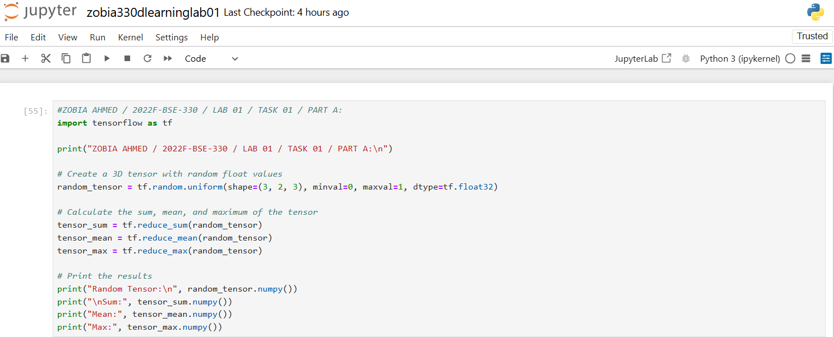

* **OUTPUT(A):**

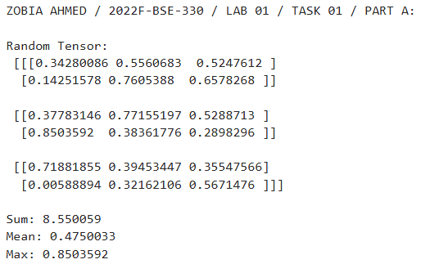

* **CODE (B):**

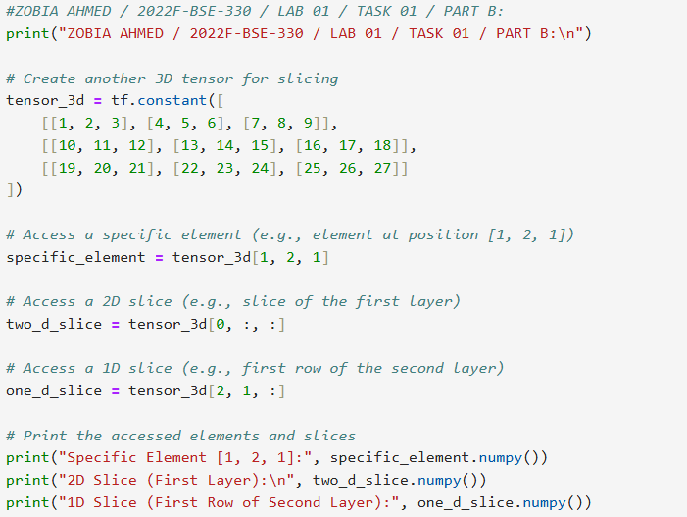

* **OUTPUT(B):**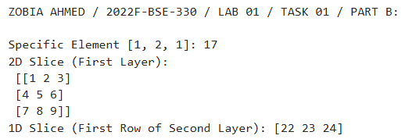

1. Create a TensorFlow function called tensor operations that takes two tensors as input and performs the following arithmetic operations:

* Addition (tensor1 + tensor2)
* Subtraction (tensor1 - tensor2)
* Multiplication (tensor1 * tensor2)
* Division (tensor1 / tensor2)

The function should return the results of these operations as a dictionary with the following keys:

* "addition"
* "subtraction"
* "multiplication"
* "division" etc

Test your function with the following tensors:

tensor1 = [10, 20, 30]

tensor2 = [5, 10, 15]

* **CODE:**

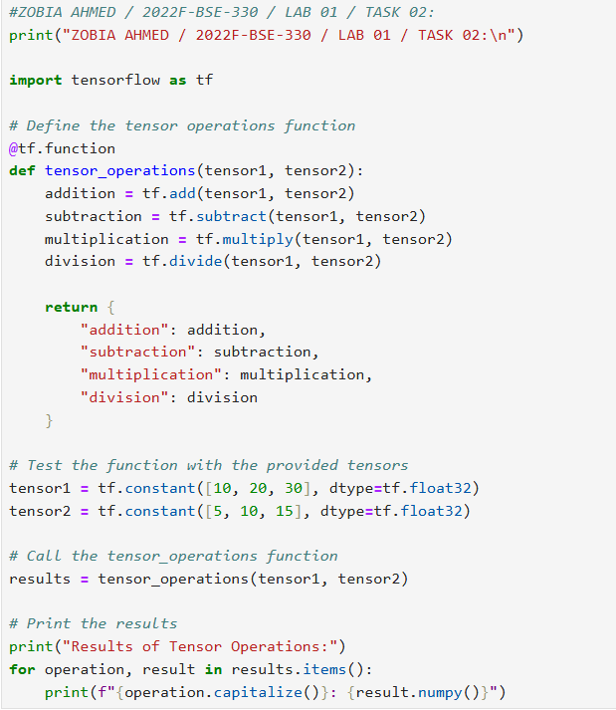

* **OUTPUT:**

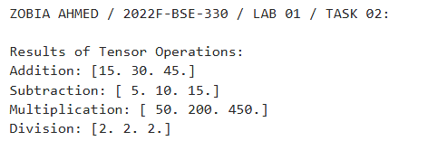

1. (A): Create a NumPy array with random float values. Sort the array in ascending and descending order. **Hint:** Use np.sort() and array slicing.

* (B): Create a 2x2 NumPy matrix. Calculate its transpose and inverse. **Hint:** Use np.transpose() and np.linalg.inv().
* (C): Create a 2D NumPy array. Calculate the sum of each row, the mean of each column, and the standard deviation of the entire array.
* **CODE (A):**

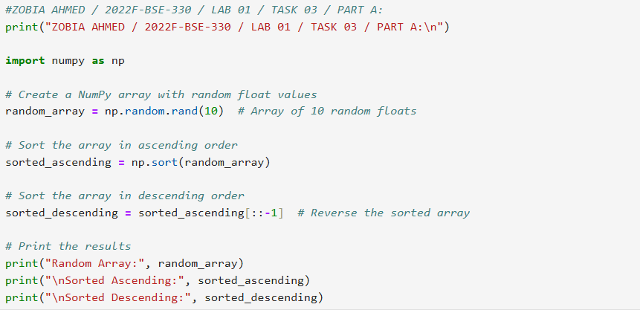

* **OUTPUT(A):**

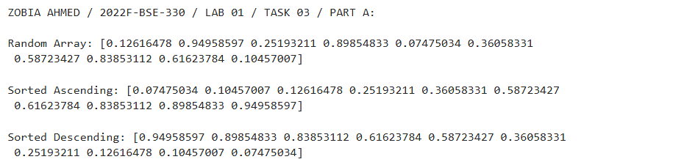

* **CODE (B):**

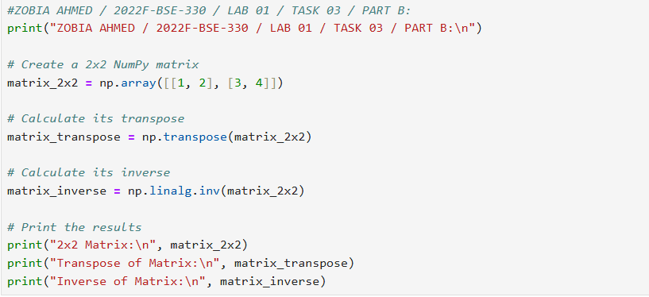

* **OUTPUT(B):**

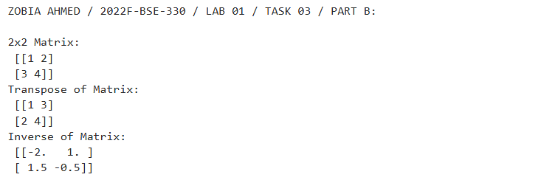

* **CODE (C):**

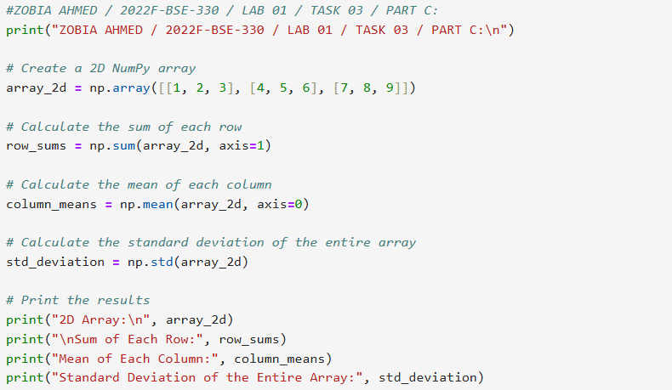

* **OUTPUT(C):**

